Teaching Science as an Act of Resistance
January 22, 2017

My views alone and not those of CSTA

Today was the Women’s March on Washington and also everywhere else. I was committed to spending the day facilitating professional development for science teachers and felt very torn about missing the march.

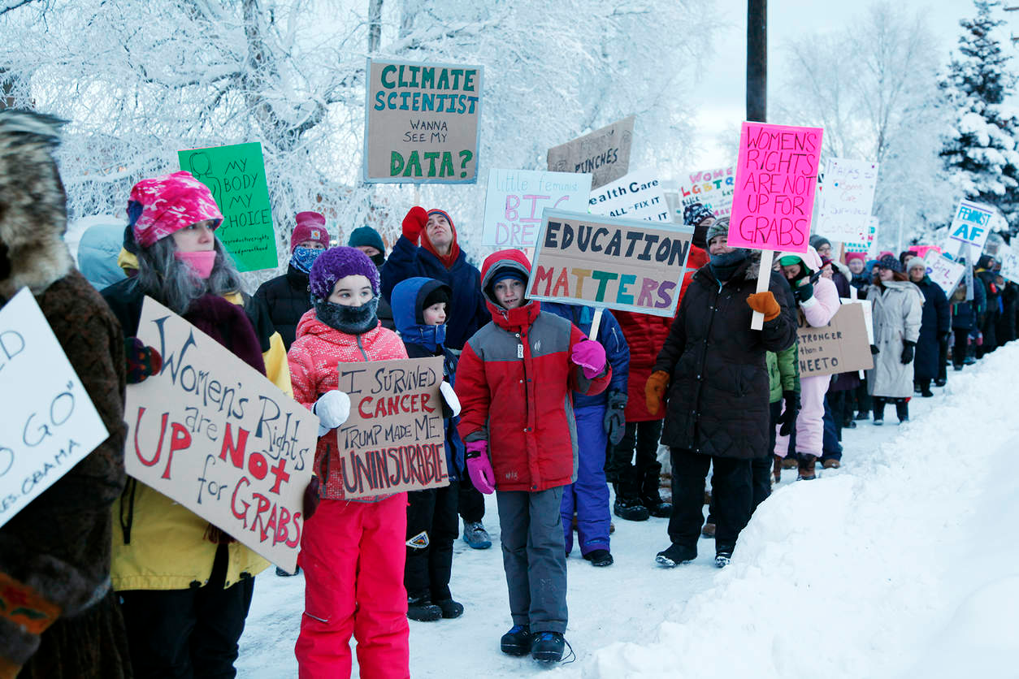
Protest in Fairbanks, Alaska
Robin Wood/Fairbanks Daily News-Miner via Associated Press

Many in the science and science education community see dark clouds ahead as a result of the inauguration. The new president has called climate science a “Chinese Hoax” , has included anti- vaxers among his advisors, and has lied and changed his story so many times as to have challenged the whole concept of objective truth. Beyond that, teachers are protective of their students. We know that our students and their families (as well as many of our colleagues) feel threatened by the new president’s rhetoric and actions toward undocumented workers, Muslim Americans, women, LGBTs, veterans, and others. We know enough about how Earth’s Systems work to understand that environmental policies that are dismissed by the new administration actually do things in the real world.

I wanted to be there for the protests: To show that the new administration has no mandate. To show my lack of consent. To show that the American people will not be “good Germans.” But I also feel that the work of science education is important. So my (possibly self-serving) question is- Can teaching science be an act of resistance?

The term “resistance” brings to mind the French Resistance and those of other nations occupied by the Nazis. It would be a vulgar delusion to compare teaching science to the bravery of those who faced the murderous fascists with their own lives as well as those of their families and communities.

Also history tells us, that much as we might idealize science, it has often served the aims of the worst. Scientists did work that supported Hitler, Stalin, and Mao. Science is not innocent. So just teaching science is not an act of resistance.

So what would it mean to teach science as an act of resistance? At its best, learning science is about learning to be a careful observer, learning to design experiments to test ideas, learning what evidence counts and why. Good science learning teaches us to ask smart questions and how to answer them. Good science teaching gives us a bullshit detector- there is no “alternative truth.”

Also scientists have learned some things about the natural world and how it works. Ideas that used to be called “conservative”, like there’s no such thing as a free lunch. This is known in science as the law of conservation of mass. This means that the resources we use come from somewhere and the waste we throw away or dump into oceans or pump into the sky go somewhere and there are consequences.
http://www.npr.org/sections/13.7/2017/01/22/510384513/fact-check-science-and-the-trump-administration?utm_source=facebook.com&utm_medium=social&utm_campaign=npr&utm_term=nprnews&utm_content=20170122

So we need to be good science teachers but we also can resist by embracing our many different kinds of students and communities. We need to look deeply at our teaching and ask if we are opening science up to all of our learners. Many of our students come from groups that haven’t produced many scientists and engineers- are we teaching to their experiences and concerns? Are we helping them see themselves as people who can use science and engineering. Is the science we teach all about “going to college” or do we show our kids that science is central to many careers and lives and gives everyone a rich understanding of the natural world?

We need to be sensitive to the fact that science has become politicized whether we intend it or not. There is a body of reasearch that shows that people will reject science messages if they see it as an attack on their identity (see the Cultural Cognition Project http://www.culturalcognition.net/ for more). We need to be careful that our science teaching is not seen as attacking student’s identity. For example- do we teach evolution in a way that puts a student into conflict with their religious beliefs? Is our message about global climate at odds with the messages a student hears about free enterprise and the evils of government regulation? To effectively teach science we need to watch to make sure we are teaching about how and why scientists arrive at their conclusions and not present science as a belief system. If our students feel backed into a corner they will not listen.

Science teaching can be an act of resistance. But resistance takes smarts and sensitivity and restraint as well as courage. And teaching science by itself is not enough. More will be asked.

I found this quote from Carl Sagan that I make me shiver with foreboding. It has so many echoes in the gloaming. Carl Sagan considered science to be a candle in the darkness. Our duty as science teachers is to keep this candle burning. This can be an act of resistance.

“I have a foreboding of an America in my children's or grandchildren's time -- when the United States is a service and information economy; when nearly all the manufacturing industries have slipped away to other countries; when awesome technological powers are in the hands of a very few, and no one representing the public interest can even grasp the issues; when the people have lost the ability to set their own agendas or knowledgeably question those in authority; when, clutching our crystals and nervously consulting our horoscopes, our critical faculties in decline, unable to distinguish between what feels good and what's true, we slide, almost without noticing, back into superstition and darkness...

The dumbing down of America is most evident in the slow decay of substantive content in the enormously influential media, the 30 second sound bites (now down to 10 seconds or less), lowest common denominator programming, credulous presentations on pseudoscience and superstition, but especially a kind of celebration of ignorance”
Carl Sagan

